
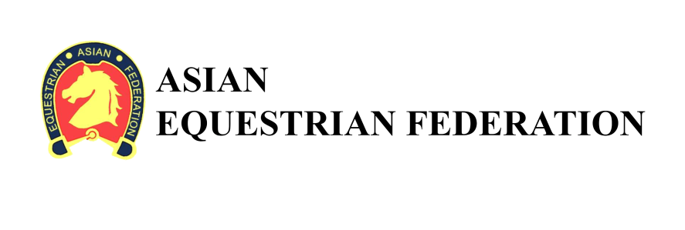

PROSPECTUS

1st Asian Equestrian Federation (AEF)
Under-21 Dressage Championship 2018

10th and 11th October 2018

Organized by


Tamil nadu
Horse
Riders
Association

1st Asian Equestrian Federation (AEF)
Under-21 Dressage Championship 2018

TECHNICAL & ADMINISTRATIVE INSTRUCTIONS

1. GENERAL:
The 1st Asian Equestrian Federation (AEF) Under-21 Dressage Championship 2018 will be conducted from 10th to 11th October 2018 according to the Rules of the Asian Equestrian Federation under the aegis of Equestrian Federation of India (EFI) by the Tamil Nadu Horse Riders Association (TNHRA) and conducted at the Chennai Equitation Centre, Chennai.

2. VENUE:
Chennai Equitation Centre, 130 Old Mahabalipuram Road, Sholinganallur, Chennai (Map Attached)

3. RULES:
Please refer to attached document “AEF U21 Dressage Championship (Final and amendment)”.

4. ENTRIES:
All entries will be on a proper Entry Form as given at Appendix 'A' and should be completed in all respects. Entries not on the prescribed entry form of without entry fee will not be considered.

- Individual Events: Rs.500/- per entry
- Entries will close by 4:00 pm on 25th Sep 2018
- Please provide copies to confirm the Riders Indian Nationality

5. PAYMENT:
All entries must be paid in cash, cheque or by NEFT transfer along with completed entry form

Account Name : EQUESTRIAN FEDERATION OF INDIA
Bank Name : Syndicate Bank
Bank Address : DHAULA KUAN, NEW DELHI-110010
Account Number : 903 0 2010 0137 40
SWIFT CODE : SYNBINBB116
BIC Code/Number : 9030
IFSC Code : SYNB0009030

6. WITHDRAWAL, CHANGE, TRANSFER OR SUBSTITUTIONS OF ENTRY:
Withdrawal: The Entry Fee of a horse / rider entered for any event will not be refunded if the horse does not participate in the competition.
Transfer and Substitutions: A horse once entered in any event cannot be substituted by another horse for any reason whatsoever.
Change of Riders: A rider once entered in any event cannot be substituted by another horse for any reason whatsoever.

7. REPORTING FOR EACH CLASS:
All horses will report to the Collecting Ring Steward half an hour before the time of judging of the class. Any entry not reporting in time will be eliminated unless the exhibitor shows good cause for the delay. The Ring Steward has full authority to take disciplinary action.

8. MEDICAL COVER:
The Organizing Committee will only provide first aid emergency treatment as well as evacuation to the hospital where necessary.

9. INSURANCE:
The Organizing Committee recommends units/clubs/associations to take insurance policies for competitors, personnel, grooms and horses during the events. The Organizing Committee will assume no responsibility for any accident or illness due to fall of any horse, competitors, grooms/any other member of the team.

10. RESPONSIBILITY:
The Organizing Committee accepts no responsibility for any loss, damage or injury to any animal or any other property or the exhibitors themselves, neither the Committee not the Doctor will be held responsible for any first aid or other medical treatment provided.

11. CAMPING AND ACCOMMODATION:
- The camp opens on 6th October, 2018 and closes on 12th October 2018.
- All teams should come fully equipped with their own grain and fodder
- The Organizers will try to arrange for Bedding straw and fodder to be made available for sale.
- All teams that require stables must send their requirements by the 4th of October 2018
- The cost of one temporary stable will be Rs.450/- per day.
- All teams must inform the organizers of their total strength (personnel and animals) by the 4th of October 2018, so that camp sites of appropriate size can be allocated for all teams.
- All teams must inform the organizers of their estimated time of arrival well in advance.
- All bio-degradable waste including horse dung is to be put into the pits provided.
- No open fires are permitted on CEC grounds.

12. COGGIN'S AND GLANDERS TESTS:
All rules and instructions issued from the EFI and Remount Veterinary Directorate, Army Headquarters on the subject will be strictly adhered to by all concerned.
All horses must produce a valid negative EIA and Glander status certificate on arrival to Chennai.
.
13. TENTATIVE PROGRAMME:
Date | Time | Name of Event | Venue
11th October 2018, Thursday | 0700 Hrs | Veterinary Check | Club House
11th October 2018, Thursday | 0800 hrs | Dressage Competition | Main Arena
11th October 2018, Thursday | 1000 hrs | Prize Distribution | Main Arena


14. VENUE MAP:

Chennai Equitation Centre
130 Old Mahabalipuram Road, Sholinganallur, Chennai 600119

Mr. Kishore Futnani, Mobile: +91-9500076968, Email: kfutnani@gmail.com

Google MAPS: https://goo.gl/maps/NAngqD6fZXU2

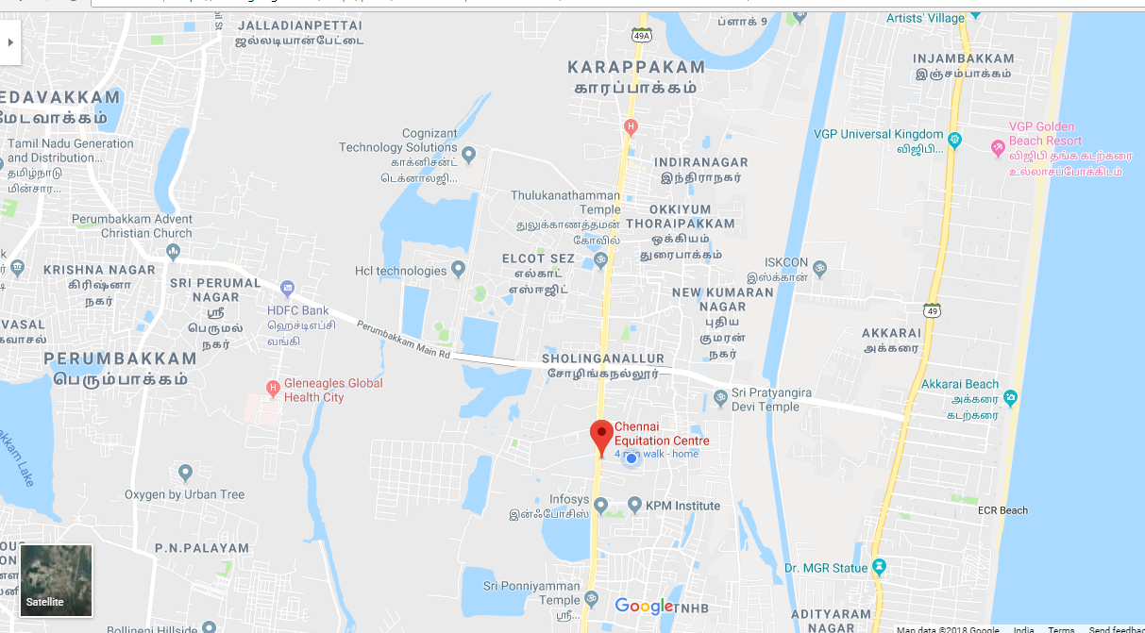

15. CORRESPONDENCE:

All correspondence in respect of the 1st AEF 2018 will be addressed to:

The Show Secretary
Mr. Kishore Futnani,
Chennai Equitation Centre
130, Old Mahabalipuram Road, Sholinganallur, Chennai 600119
Mobile: +91-98404 34554, Email: kfutnani@gmail.com
Appendix ‘A’

ENTRY FORM
ASIAN EQUESTRIAN FEDERATION (AEF) UNDER-21 DRESSAGE CHAMPIONSHIP 2018

Name of Unit / Club:
Sl.  No | RIDER |  |  | HORSE |  |  |  | Entry  Fee
Sl.  No | Mr / Ms / Mrs | Name | DOB | Name | Colour | Sex | Age | Entry  Fee
 |  |  |  |  |  | Total Fee

Name:
Signature:
Mobile No:
Date:

